Evaluation of campaign in Hong Kong Institute of Technology (HKIT)
The Aims of the campaign in Hong Kong Institute of Technology was to Foster an inclusive atmosphere at campus and to Increase students, Teachers’ and Staff’s Awareness of SEN students. Therefore, to achieve these aims in HKIT, QESS project team had done three events.
- Exhibition board display in various campus
To Foster an inclusive atmosphere at campus and to Increase students, Teachers’ and Staff’s awareness of SEN students,QESS Project team had put posters and contact method of QESS Project team members in campus in various regions, including Tsuen Wan, Kwun Tong, Cheung Sha Wan, Tuen Mun and Sham Shui Po campus. Photos of the exhibition board has been attached in Appendix A.
Evaluation method
To Evaluate the effectivness of the exhibition board display, questionaires (see Appendix B ) was attached to the exhibition board. The evaluation form of the exhibition board would be recived and hand back to the QESS team for evaluation. Items on measuring the design of the exhibition board, Conent of the exhibition board and enhancment on SEN knowledge was included in the evaluation form. Each item was self-rated on a 5 piont liker scale. Socres will be recored and anyized to evaluate the effectivness of the exhibition board display.
Results
The original evaluation mechanism of the exhibition boards involes questionaires of measures on the design, content and enhancement on SEN knowledges. However, with in the timeframe on the display of the QESS exhibition board, there was 0 evaluation form recived. Therefore, evaluation of the exhibition board display cannot be done by the evaluation form.
Despite with 0 resposnse rate on the eveluation form, numbers of enquiqies was been recived by QESS project team through out the display period of the exhibition board,referals from teachers in HKIT was also recived. Follow ups was made and meetings was arranged in students request.
Potenial inprovement on Exhibition board display
For further inprovments regarding on 0 response rate on the evelauation form, in-class promotions can be done to increase the awarness on our exhibition board displays. Also, evaluation methods can be more direct by
distributing the evaluation form actively to the students which had reviewed the exhibition board

- In Class Sessions
Two teachers agreed for QESS Project team to conduct in-class sessions in their class. Students studying in sub-degree, degree and Yi Jin level were included, as the aim of the campaign is to create whole-school inclusive atmosphere at campus.
There were totally 34 students participated in the in-class sessions.Photos of in-class sessions have been attached in Appendix C.

The following table shows the details of the in-class sessions:
 | First in-class sessions | Second in-class sessions
Date | 29 October 2015 | 4 November 2015 (First session)  11 November 2015 (Second session)  18 November 2015 (Third session)
Time | 10:30-12:00 | 17:30-18:00 (First session)  17:00-17:30 (Second session)  17:00-17:30 (Third session)
Venue | Sham Shui Po Campus of HKIT | Sham Shui Po Campus of HKIT
Participants | 30 (9 of them have completed signed consent form, pre- and post-measures) | 32 (28 of them have completed signed consent form, pre- and post-measures)
Background of participants | Students studying degree level (The course “Social Research Methods”) | Students studying Yi Jin Level  (The course “Communication Psychology”)
Remarks | As requested by the subject teacher, the three in-class sessions were combined into one session | /

Evaluation method
To evaluate the In Class sessions, all participants were asked to complete consent forms, pre- and post-measures, as well as satisfaction questionnaires. The sample of the evaluation forms of the In Class sessions is attached in the current report (see Appendix D- G). The evaluation was separated into SEN knowledge, SEN attitude and Level Satisfaction of in-class sessions in-order to access the effectiveness of the In Class sessions. To measure the SEN knowledge, Pre and post measures of 7 items of true and false questions are taken to analyze the SEN knowledge change after the In Class sessions. To measure the SEN Attitude, Pre and post measures of 4 items in 5 Liker points are taken to analyze the SEN Attitude change after the In Class sessions. To measure the Level of Satisfaction of the In-Class sessions, 10 items in 5 Liker points are taken to measure the levels of satisfaction of the In Class sessions.
Results
The In- Class sessions are separated into two rounds, the first round of In-Class session was conducted on 29 October 2015. The original plan on the In-class sessions was divided into 3 sessions, but as requested by the subject teacher, the three In-class sessions were combined into one session. There was 30 participants attended, but only 9 participants completed and returned all consent forms, pre and post measures and the satisfaction measures.
The Second round of the In-class sessions was conducted in 3 sessions starting on 4 November 2015, 11 November 2015 and 18 November 2015. There was 32 Participants attended, 28 participants completed and returned all consent forms, pre and post measures and satisfaction measures.

Pre and post measures of Knowledge and Attitude
After analyzing pre and post measures on both SEN knowledge and SEN Attitude, statistics are compared. The following table summarizes the statistics of the pre and post measures of SEN knowledge and SEN Attitude.

Paired Samples Statistics
 |  | Mean | N | Std. Deviation | Std. Error Mean
Pair 1 | Pre-Knowledge | 5.71 | 34 | .970 | .166
 | Post-Knowledge | 6.03 | 34 | 1.141 | .196
Pair 2 | Pre-Attitude | 13.97 | 33 | 2.592 | .451
 | Post-Attitude | 14.55 | 33 | 2.489 | .433

There are total 37 participants on both measures, excluding the missing responses of pre and post measures; there are 34 responses in Pre and Post measures of SEN Knowledge and 33 responses in the pre and post measures of SEN Attitude.
In the pre and post measures of SEN knowledge, the mean score of Pre measures of SEN knowledge was 5.71, the Standard deviation of the Pre measures are 0.97. The mean score of Post measures of SEN knowledge was 6.03, the Standard deviation of the Post measures are 1.141.
In the pre and post measures of SEN Attitude the mean score of Pre measures of SEN Attitude was 13.97, the Standard deviation of the Pre measures are 2.592. The mean score of Post measures of SEN Attitude was 14.55, the Standard deviation of the Post measures are 2.489.
Pair sample t-test was performed to compare the difference on both pre and post measures of both SEN knowledge and SEN Attitude. The following table summarizes the statistics of the Paired sample test.

Paired Samples Test
 |  | Paired Differences |  |  |  |  | t | df | Sig. (1-tailed)
 |  | Mean | Std. Deviation | Std. Error Mean | 95% Confidence Interval of the Difference
 |  |  |  |  | Lower | Upper
Pair 1 | Pre-Knowledge - Post-Knowledge | -.324 | 1.492 | .256 | -.844 | .197 | -1.265 | 33 | .215*
Pair 2 | Pre-Attitude - Post-Attitude | -.576 | 2.359 | .411 | -1.412 | .261 | -1.402 | 32 | .171*

Mean difference are compared between pre measures and post measures on both SEN Knowledge and SEN Attitude.The mean difference on the SEN knowledge between pre and post measure is -0.324 and was found statistically significant ( p< .25). The mean difference on the SEN Attitude between pre and post measures is -0.576 and was also found statistically significant (p < .25).
According to the statistical result, after the In-Class sessions where conducted, there are a increase on both SEN knowledge and SEN Attitude on the mean of pre and post measures and both mean difference are statistically significant ( p < .25).

Level of Satisfaction
The total score of the Level of satisfaction is averaged and analyzed .The following table summarizes the statistics of the Level of Satisfaction on the In-class session.

Descriptive Statistics
 | N | Minimum | Maximum | Mean | Std. Deviation | Skewness |  | Kurtosis
 | Statistic | Statistic | Statistic | Statistic | Statistic | Statistic | Std. Error | Statistic | Std. Error
Level of satisfaction | 34 | 2.80 | 5.00 | 3.9853 | .59193 | .189 | .403 | -.374 | .788
Valid N (listwise) | 34

There are total 37 participants responded on the Level of Satisfaction, excluding the missing responses there are 34 responses in Level of satisfaction. The mean of the Level of Satisfaction is 3.9853 and the standard deviation is 0.59193. Frequencies of the scores on the Level of satisfaction is recorded and plotted to the following histogram.
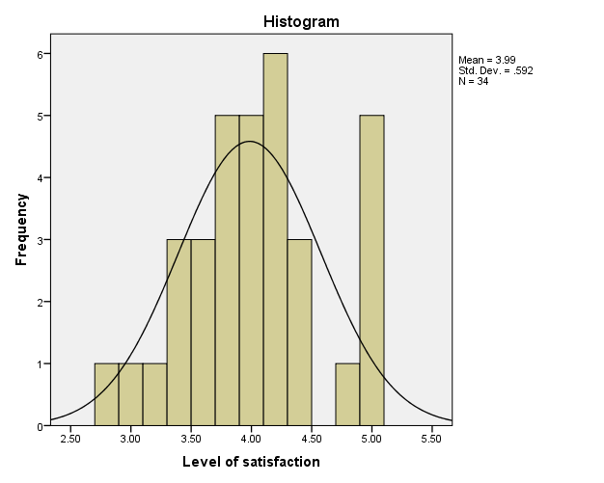
According to the statistic result, most frequent score is around 4 to 5. The results showed that the Level of Satisfaction on the In-Class session is quite satisfied.
Sub-Scores on Level of Satisfaction
The level of satisfaction was also separated into 4 sub-scores, which indicate the satisfaction to the content, satisfaction to the teacher, satisfaction to the location and the satisfaction to the time on the In-Class sessions.
The following table summarizes the statistics of 4 sub-scores on the level of satisfaction.

Descriptive Statistics
 | N | Mean | Std. Deviation
Satisfaction_content | 34 | 3.9191 | .67060
Satisfation_teacher | 34 | 4.2451 | .67823
Satisfaction_location | 34 | 4.0882 | .79268
Satisfaction_time | 34 | 3.6765 | .94454
Valid N (listwise) | 34

The mean of the satisfaction to the content is 3.9191 out of 5 point score and the standard deviation is 0.67060. The mean of the satisfaction to the teacher is 4.2451 out of 5 point score and the standard deviation is 0.67823. The mean of the satisfaction to the location is 4.0882 out of 5 point score and the standard deviation is 0.79268. The mean of the satisfaction to the time is 3.6765 out of 5 point score and the standard deviation is 0.94454.
Also, general comments are collected from students; many students reported that the In-Class session had benefited them on the knowledge on students with special educational needs
Potential improvements on the In-Class sessions
According to general comments recorded from participated students, 2 students commented that the duration of the session was too long. Also, the In-Class sessions was successful on getting students to know more about SEN, therefore for further improvements on the In-class sessions, the duration of each session could have some adjustment and can arrange on cover more students to increase the influence between students to foster an inclusive atmosphere at school.

- Ad Hoc event: Promotion booth in information dayof Hong Kong Institute of Technology (HKIT)
While HKIT was holding the Information day for the 2015-2016 academic years, QESS team was invited to set up a booth of the information day.

The following table shows the details of the booth of the information day.
 | Details
Date | 19 December 2015
Time | 9:00-16:00
Venue | Room 101, Sham Shui Po Campus, HKIT

The rundown of the booth is shown in the following table:
Step | Activity | Objective
1 | QESS team members invite the students to come to the booth | Attracting students to come to the booth
2 | General Health Questionnaire (see Appendix H)/ Embedded Figure Test (see Appendix I) were distributed to the students | Enhancing students’ interest on issues related to special educational needs (SEN)
3 | Debriefing:  General Health Questionnaire: Students’ performance may be affected by the pressure, but some of the students’ performance are affected by biological / genetic factors (i.e. dyslexia, autism spectrum disorders)  Embedded Figure Test: Students with autism can finish the task in a very short period, as they are detail-minded | Enhancing students’ understanding on the characteristics of students living with SEN/ Enhancing the sense of “sameness” between ordinary students and SEN students
4 | Leaflets were distributed to the students (see Appendix J) | Enhancing students’ understanding in support mechanism in HKIT for SEN students

Results
According to the head count on the information day, the QESS promotion booth had record around 60 to 80 students attending our QESS booth.
Most of the students went through all the activity of the booth, and the response was very satisfied. Many students had claimed that after the activities, they knew more about characteristics of autisms and have more understandings on SEN. Also, during the booth, one SEN student approached our QESS team and shared his experience and difficulties to our team, conversations were taken during gap times between sessions.
According to the HKIT’s information day report, the QESS promotion booth was ranked the second popular booth in the information day.

Conclusion on the campaign in HKIT
The campaign in HKIT was successful regarding to the participation rate and the involvements of the students and effectiveness of each event in our campaign. The events of the campaign were able to foster an inclusive atmosphere at campus and to Increase students, Teachers’ and Staff’s awareness of SEN students. Also feedback and comments of each event were mainly positive.

Appendix A
Photo 1. Exhibition board in Tsuen Wan Campus
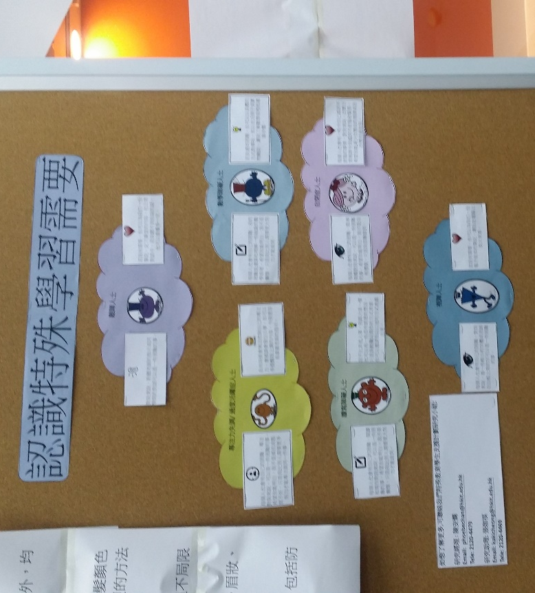

Photo 2. Exhibition board in Kwun Tong Campus
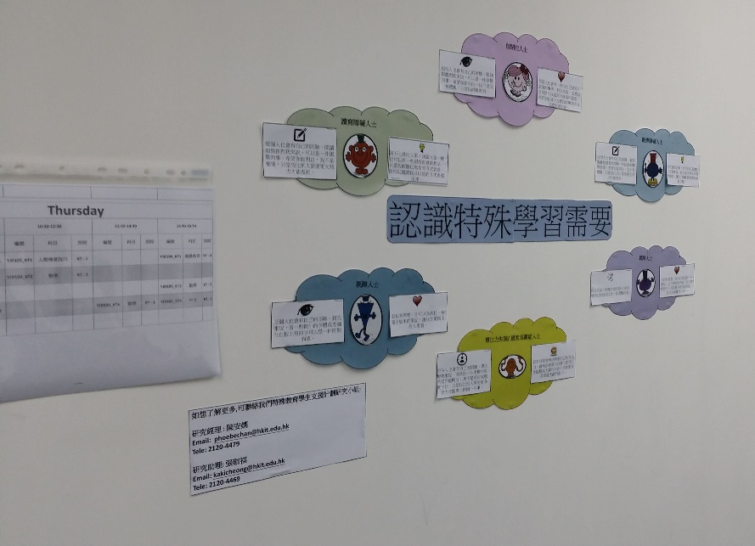

Photo 3. Exhibition board in Cheung Sha Wan Campus
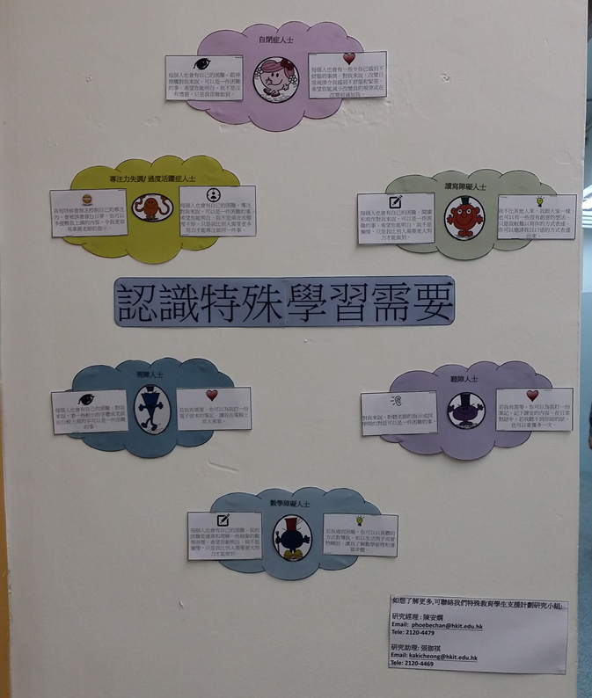

Photo 4. Exhibition board in Tuen Mun Campus
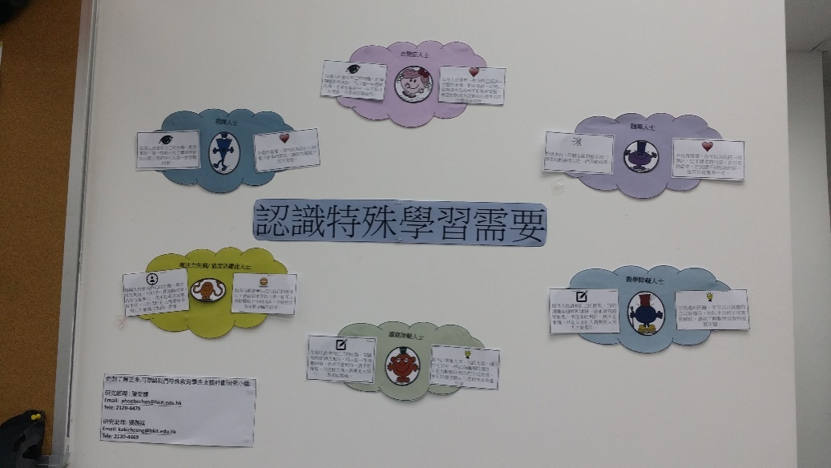

Appendix B
Exhibition board Questionaire

題目
- 我認為「認識特殊教育需要」璧報的設計很好 (例如：排版和顏色配搭) | 1 / 2 / 3 / 4 / 5
- 我認為「認識特殊教育需要」璧報的內容十分豐富 | 1 / 2 / 3 / 4 / 5
- 我認為「認識特殊教育需要」璧報的內容能增進我對特殊教育需要的知識 | 1 / 2 / 3 / 4 / 5
(Note: 1 = 完全不同意; 2 = 不同意; 3 = 中立; 4 = 同意; 5 = 完全同意)

4. 其他意見：
__________________________________________________________________________________________________________________________________________________________________________________________________________________________________________

Appendix C
Photo of in-class session
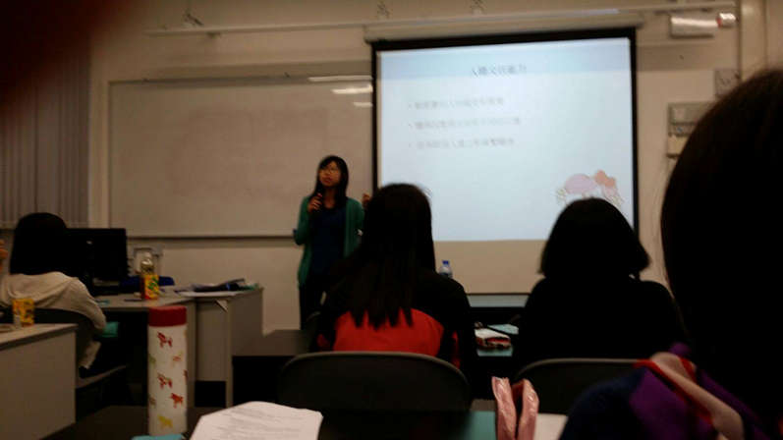

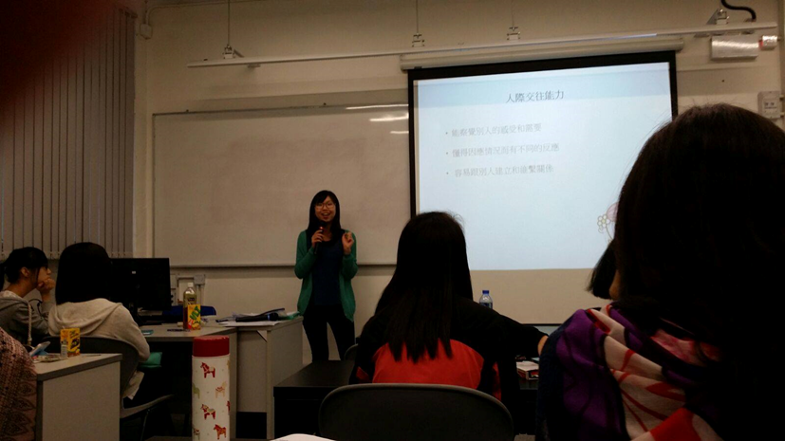

Appendix D

Pre-test Questionnaire on Knowledge

參加者編號：_____________________________
請圈出正確答案
題目
- 讀寫障礙跟學習態度不好有關 | 正確 / 錯誤
- 讀寫障礙的其中一個成因為視力不好，導致看不到文字 | 正確 / 錯誤
- 讀寫障礙的其中一個成因為遺傳因素 | 正確 / 錯誤
- 讀寫障礙和自閉症都屬於有特殊學習需要 | 正確 / 錯誤
- 自閉症人士十分喜歡改變，希望有更多的文字刺激 | 正確 / 錯誤
- 所有自閉症人士都喜歡巴士和火車 | 正確 / 錯誤
- 自閉症和家庭管教模式有關 | 正確 / 錯誤

Appendix E
Post-test Questionnaire on Knowledge

參加者編號：_____________________________
請圈出正確答案
題目
- 讀寫障礙是因為缺乏學習動機 | 正確 / 錯誤
- 讀寫障礙看到的東西和其他人不同，他們看不到文字 | 正確 / 錯誤
- 讀寫障礙跟後天因素有關，先天因素（如遺傳）跟讀寫障礙沒有關係 | 正確 / 錯誤
- 讀寫障礙和自閉症都有一個共通點：他們屬於有特殊學習需要這個範疇以內 | 正確 / 錯誤
- 很多自閉症人士都不喜歡改變 | 正確 / 錯誤
- 很多自閉症人士都十分注重細節 | 正確 / 錯誤
- 自閉症的起因和家庭管教模式無關 | 正確 / 錯誤

Appendix F
Questionnaire on Attitude
題目
- 我認為一些學習能力或人際溝通能力較弱的同學應該就讀主流學校(例如：HKIT)，而不是特殊學校 | 1 / 2 / 3 / 4 / 5
- 我認為一些學習能力或人際溝通能力較弱的同學也應該有機會入讀主流學校(例如：HKIT) | 1 / 2 / 3 / 4 / 5
- 我會跟一些學習能力或人際溝通能力較弱的同學做朋友 | 1 / 2 / 3 / 4 / 5
- 我會跟一些學習能力或人際溝通能力較弱的同學一組做專題研習 | 1 / 2 / 3 / 4 / 5
(Note: 1 = 完全不同意; 2 = 不同意; 3 = 中立; 4 = 同意; 5 = 完全同意)

參加者編號：_________________________________________

Appendix G
Questionnaire on Level of Satisfaction

參加者編號：_______________________________________
Item Sample
- 我認為課程內容有趣 | 1 / 2 / 3 / 4 / 5
- 我認為課程內容與緊扣主題 (i.e. 特殊教育需要) | 1 / 2 / 3 / 4 / 5
- 我認為課程內容有實用性 | 1 / 2 / 3 / 4 / 5
- 我認為課程內容是全面的 | 1 / 2 / 3 / 4 / 5
- 我認為課程導師對特殊教育需要有豐富的知識 | 1 / 2 / 3 / 4 / 5
- 我認為課程導師對課程有充分的準備 (i.e. PowerPoint) | 1 / 2 / 3 / 4 / 5
- 我認為課程導師有營造一個好的學習和討論的環境 | 1 / 2 / 3 / 4 / 5
- 我認為課程的地點合適 | 1 / 2 / 3 / 4 / 5
- 我認為課程所選擇的時間是合適的 | 1 / 2 / 3 / 4 / 5
- 我認為課時長度是合適的 | 1 / 2 / 3 / 4 / 5
(Note: 1 = 完全不同意; 2 = 不同意; 3 = 中立; 4 = 同意; 5 = 完全同意)

- 這個課程有什麼令你印象深刻的地方?
__________________________________________________________________
__________________________________________________________________
__________________________________________________________________
- 這個課程有什麼地方需要改善?
__________________________________________________________________
__________________________________________________________________
__________________________________________________________________
Appendix G

13. 你對這個課程有什麼其他意見?
__________________________________________________________________
__________________________________________________________________
__________________________________________________________________

Appendix H
General Health Questionnaire
請問你在最近一個月內是不是：
B1. 做事能集中精神？ | 比平時好一點 | 和平時一樣 | 比平時差一點 | 比平時差很多
B2. 曾因擔憂而失眠? | 一點也不 | 和平時差不多 | 比平時多一點 | 比平時多很多
B3. 覺得自己能擔當有用的角色? | 比平時有用 | 和平時一樣 | 比平時沒用 | 比平時更沒用
B4. 覺得自己處事能拿定主意? | 比平時多一些 | 和平時一樣 | 比平時少一些 | 比平時少很多
B5. 覺得總是有精神壓  力? | 一點也不 | 和平時差不多 | 比平時多一些 | 比平時多很多
B6. 覺得無法克服困  難? | 一點也不 | 和平時差不多 | 比平時多一些 | 比平時多很多
B7. 覺得日常生活有趣味? | 比平時多一些 | 和平時一樣 | 比平時少一些 | 比平時少很多
B8. 能夠勇敢面對問題? | 比平時多一些 | 和平時一樣 | 比平時少一些 | 比平時少很多
B9. 覺得心情不快樂及憂鬱? | 一點也不 | 和平時差不多 | 比平時多一些 | 比平時多很多
B10. 對自己失去信心? | 一點也不 | 和平時差不多 | 比平時多一些 | 比平時多很多
B11. 覺得自己沒用? | 一點也不 | 和平時差不多 | 比平時多一些 | 比平時多很多
B12. 大致上感到快樂? | 比平時多一些 | 和平時一樣 | 比平時少一些 | 比平時少很多

Appendix I
Embedded Figure Test

Appendix J
Leaflet (Font and back side)
