Implementation of campaign in Hong Kong Institute of Technology (HKIT)
Aims: (1) Fostering an inclusive atmosphere at campus
(2) Increasing students’, teachers’ and staffs’ awareness of SEN students
- In-class sessions
Two teachers agreed for QESS Project team to conduct in-class sessions in their class. Students studying in sub-degree, degree and Yi Jin level were included, as the aim of the campaign is to create whole-school inclusive atmosphere at campus. There were totally 34 students participated in the in-class sessions, with completed pre- and post-measures, as well as satisfaction questionnaire. Photos of in-class sessions have been attached in Appendix A.

The following table shows the details of the in-class sessions:
 | First in-class sessions | Second in-class sessions
Date | 29 October 2015 | 4 November 2015 (First session)  11 November 2015 (Second session)  18 November 2015 (Third session)
Time | 10:30-12:00 | 17:30-18:00 (First session)  17:00-17:30 (Second session)  17:00-17:30 (Third session)
Venue | Sham Shui Po Campus of HKIT | Sham Shui Po Campus of HKIT
Participants | 9 (with signed consent form, pre- and post-measures) | 25 (with signed consent form, pre- and post-measures)
Background of participants | Students studying degree level (The course “Social Research Methods”) | Students studying Yi Jin Level  (The course “Communication Psychology”)
Remarks | As requested by the subject teacher, the three in-class sessions were combined into one session | /

- Exhibition board display in various campus
QESS Project team had put posters and contact method of QESS Project team members in campus in various regions, including Tsuen Wan, Kwun Tong, Cheung Sha Wan, Tuen Mun and Sham Shui Po campus. Photos of the exhibition board has been attached in Appendix B.

- Ad Hoc event: Promotion booth in information day of Hong Kong Institute of Technology (HKIT)

QESS team was invited to set up a booth in the information day of HKIT.

The following table shows the details of the booth of the information day:
 | Details
Date | 19 December 2015
Time | 9:00-16:00
Venue | Room 101, Sham Shui Po Campus, HKIT

The rundown of the booth is shown in the following table:
Step | Activity | Objective
1 | QESS team members invite the students to come to the booth | Attracting students to come to the booth
2 | General Health Questionnaire (see Appendix D)/ Embedded Figure Test (see Appendix E) were distributed to the students | Enhancing students’ interest on issues related to special educational needs (SEN)
3 | Debriefing:  General Health Questionnaire: Students’ performance may be affected by the pressure, but some of the students’ performance are affected by biological / genetic factors (i.e. dyslexia, autism spectrum disorders)  Embedded Figure Test: Students with autism can finish the task in a very short period, as they are detail-minded | Enhancing students’ understanding on the characteristics of students living with SEN/ Enhancing the sense of “sameness” between ordinary students and SEN students
4 | Leaflets were distributed to the students (see Appendix C) | Enhancing students’ understanding in support mechanism in HKIT for SEN students
There were 80 students visited the booth. By the QESS team members’ observation, students showed appreciation on SEN students’ strengths after doing the embedded figure test and realized that students with autism spectrum disorders can have faster and more accurate answer than them.

Appendix A
Photo of in-class session
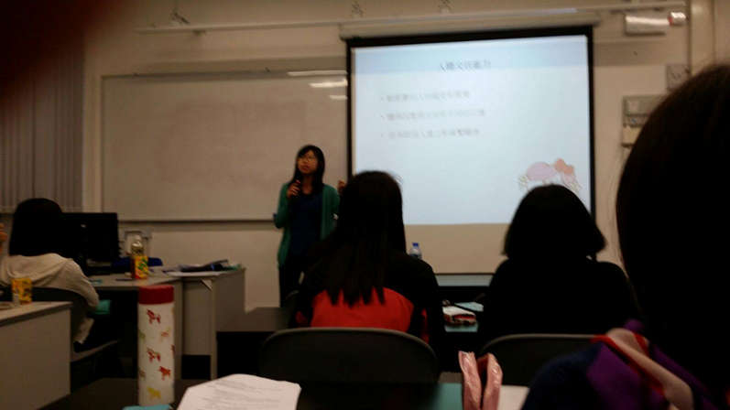

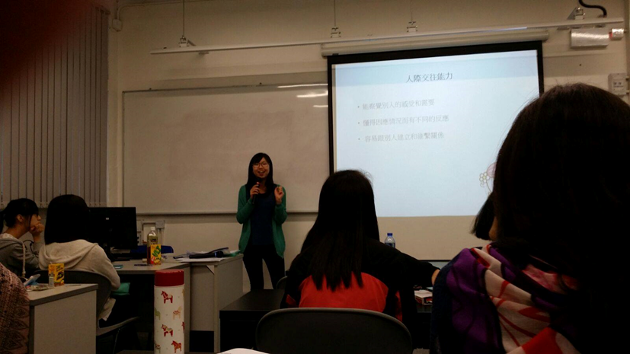

Appendix B
Photo 1. Exhibition board in Tsuen Wan Campus
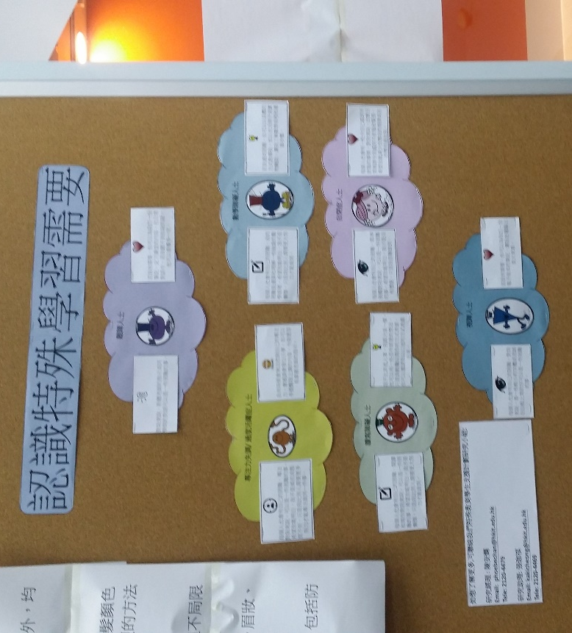
Photo 2. Exhibition board in Kwun Tong Campus
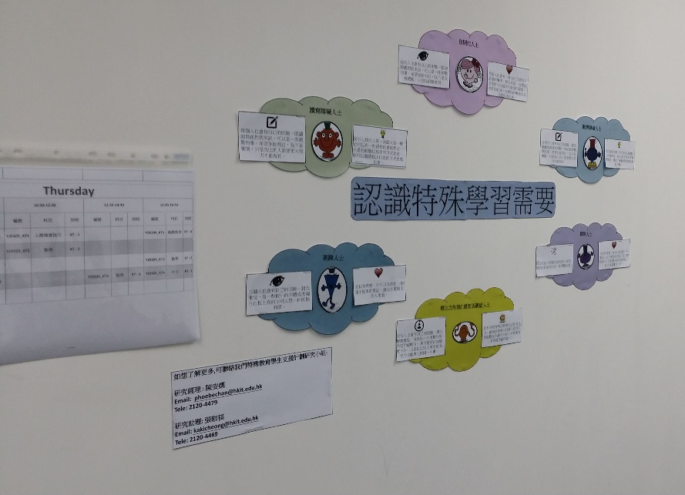

Photo 3. Exhibition board in Cheung Sha Wan Campus
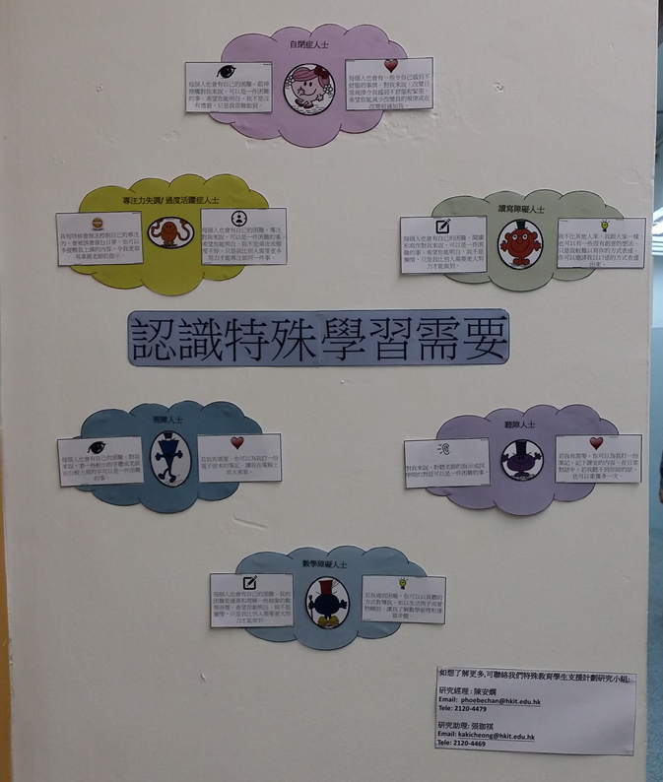

Photo 4. Exhibition board in Tuen Mun Campus
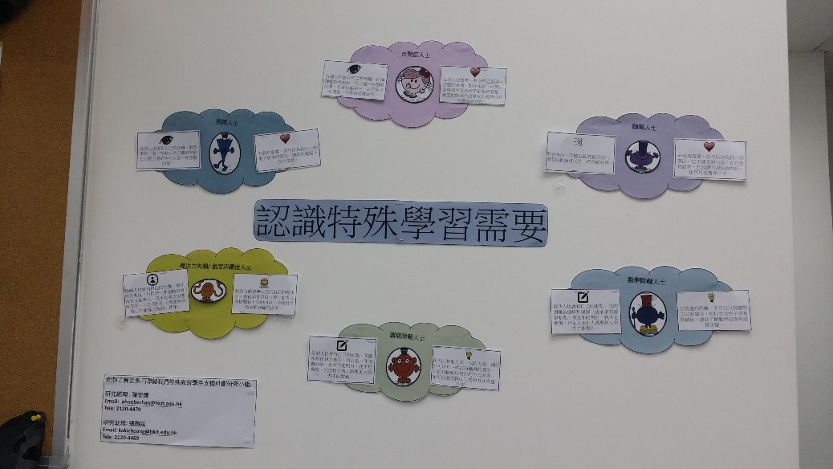
Appendix C
Leaflet (Font and back side)
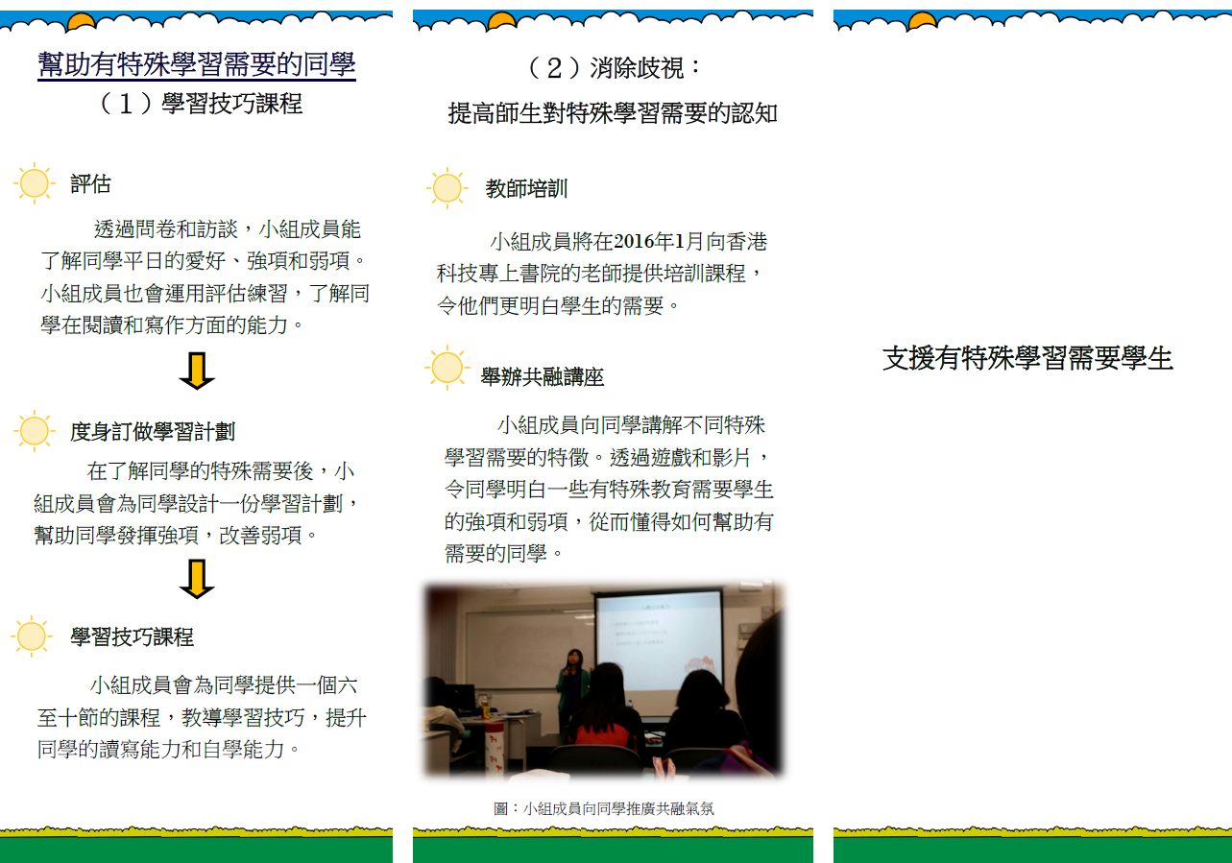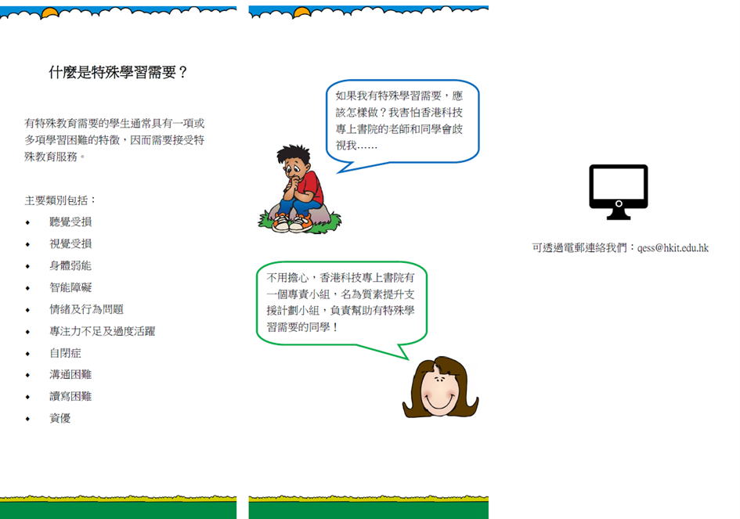
Appendix D
General Health Questionnaire
請問你在最近一個月內是不是：
B1. 做事能集中精神？ | 比平時好一點 | 和平時一樣 | 比平時差一點 | 比平時差很多
B2. 曾因擔憂而失眠? | 一點也不 | 和平時差不多 | 比平時多一點 | 比平時多很多
B3. 覺得自己能擔當有用的角色? | 比平時有用 | 和平時一樣 | 比平時沒用 | 比平時更沒用
B4. 覺得自己處事能拿 定主意? | 比平時多一些 | 和平時一樣 | 比平時少一些 | 比平時少很多
B5. 覺得總是有精神壓  力? | 一點也不 | 和平時差不多 | 比平時多一些 | 比平時多很多
B6. 覺得無法克服困  難? | 一點也不 | 和平時差不多 | 比平時多一些 | 比平時多很多
B7. 覺得日常生活有趣味? | 比平時多一些 | 和平時一樣 | 比平時少一些 | 比平時少很多
B8. 能夠勇敢面對問題? | 比平時多一些 | 和平時一樣 | 比平時少一些 | 比平時少很多
B9. 覺得心情不快樂及憂鬱? | 一點也不 | 和平時差不多 | 比平時多一些 | 比平時多很多
B10. 對自己失去信心? | 一點也不 | 和平時差不多 | 比平時多一些 | 比平時多很多
B11. 覺得自己沒用? | 一點也不 | 和平時差不多 | 比平時多一些 | 比平時多很多
B12. 大致上感到快樂? | 比平時多一些 | 和平時一樣 | 比平時少一些 | 比平時少很多

Appendix E
Embedded Figure Test

