Implementation report of teacher training session in Hong Kong Institute of Technology (HKIT)
QESS project team has conducted a teacher training session on working with students with special educational needs (SEN) in HKIT. The objectives of the teacher training session were (1) fostering positive attitude towards students with SEN; (2) enhancing teachers’ knowledge on working with students with SEN; and (3) equip the teachers with teaching skills of accommodating students with SEN in mainstream classroom.

Promotion of the teacher training session
Before the teacher training session, members of QESS project team invited teaching staffs in HKIT to participate in the teacher training session through email. The email content of invitation letter (see Appendix A and B) has been attached to the current report. Five teaching staffs responded to the invitation letter through email and three of them agreed to join the teacher training session.
In order to reach all of the teaching staffs, QESS project team prepared a memo (see Appendix C) for inviting teaching staffs to join the session and distributed to them in person. Twelve teaching staffs indicated their interest on teacher training session while some of the teaching staffs replied that they cannot participate, due to time clash with other duties.
Additionally, member of QESS project team also reminded the teaching staffs to participate in the teacher training session in joint-staff meeting on Wednesdays.

Implementation of the teacher training session
Teacher training session was held on 20 January 2016, from 14:30 to 17:30, in the conference room in the back office of HKIT. The teacher training session has been divided into various sub-parts. Detailed rundown of the session has been attached to the current report (see Appendix D). The following table shows the details of each sub-part and their goals:
Part | Content | Goal
1: SEN basics | Introduction of characteristics and etiology of various kind of SEN | - Enhancing teachers’ basic knowledge on SEN  - Fostering teachers’ positive attitude on SEN students through connecting the presenting problems of SEN students to biological and genetic factors
2: Universal design for learning | Introduction of universal instructional design that appropriate for both non-SEN and SEN students | - Equip the teachers with teaching skills of accommodating students with SEN in mainstream classroom
3: Review of screening tool | Brief introduction of the ideas of the screening tool developing by HKIT and external consultant team | - Enhancing teachers’ basic knowledge on identification tool that will be used in HKIT
4: Sharing of cases in HKIT | Review on the background of the SEN students that QESS project team is working with; and the progress of sessions conducted by QESS team | - Enhancing teachers’ basic knowledge on SEN students’ condition in HKIT  - Fostering teachers’ positive attitude on SEN students through real case sharing
5: Coping strategies | Introduction of practical coping strategies (i.e. classroom management skills) | - Equip the teachers with teaching skills of accommodating students with SEN in mainstream classroom  - Enhancing teachers’ coping strategies when encountering emotional and behavioral issues of SEN students
6: Existing resources for SEN students | Introduction of assistive technologies can be used by SEN students and internal resources (i.e. their strengths and protective factors) that teachers can help developing | - Enhancing teachers’ knowledge on the assistive technologies that can help students to learn and self-study  - Enhancing teachers’ positive attitude on SEN students through emphasizing the potentials and strengths of SEN students

16 teaching staffs, who are currently teaching arts, business (including accounting and business management), building services, mathematics and computing participated in the training session. The photos of the teacher training session were attached to the current report (see Appendix E).
Appendix A
Email content of invitation letter (Eng)
Dear all,
Subject: Teacher training session for teaching staffs in HKIT on working with students with special educational needs (SEN)
It is our pleasure to invite you to attend a workshop about “Working with students with special educational needs (SEN)”. The workshop aims to enhance teaching staffs’ knowledge on SEN and build up inclusive atmosphere in our institution.
Details:
Date: 20 Jan 2016 (Wed)
Time: 14:30-17:30
Venue: Conference room, Park office
Session highlights:
- Specialists from The Hong Kong Polytechnic University
- Useful skills on working with SEN students (i.e. teaching strategies that can be used in classroom and practical coping strategies)
- Existing resources can be utilized by HKIT students
- Real cases sharing in HKIT
The session will be divided into six parts. Details of each part can be found in the attachment.
In addition to learning and skills development, the session will provide a valuable opportunity for those involved to meet together and encourage each other. It is hoped that it will also be a time for participants to recuperate so as to be able to return to their work with new energy.
We would appreciate it if you would notify us as soon as possible as to whether you will be able to attend this session. You attendance will be recorded by Staff Development Committee and recognized as one of the staff development activities. You are reminded to seek for your supervisor's approval prior to join the session.
For any enquiry, please do not hesitate to contact Ms. Phoebe Chan (QESS Project Manager) via email (phoebechan@hkit.edu.hk) or phone call (159).
QESS Project team

Appendix B
Email content of invitation letter (Chinese)
質素提升支援計劃小組
「教師培訓工作坊：支援特殊學習需要學生」
邀請函
各位HKIT的同工：
為了提升本校教學人員對特殊學習需要（SEN）的認識和加強學校共融的氣氛，質素提升支援計劃小組現舉辨一節教師培訓工作坊，誠邀全校教學人員參與。詳情如下：

日期：二零一六年一月二十日（星期三）
時間：下午二時三十分至五時三十分
地點：Park office的會議室
工作坊由來自理工大學的專家和質素提升支援計劃小組成員主講。其中精彩內容包括：
- 支援特殊學習需要學生的實用技巧（教學法和課堂管理技巧）
- HKIT的SEN學生可用的社區資源
- 真實個案分享（兩名HKIT的SEN學生）
工作坊將會分為六個部份，詳情可參考附件。
你的參與除了令自身的知識和技巧有所提升外，對本校的SEN學生亦有莫大的裨益。我們誠邀你一同參與。你的參與將會被本校的職員發展委員會紀錄，作為其中一項職員發展活動。在參與工作坊前，你可以詢問你的上司，得到他們的批准，參與活動。謹請蒞臨！
如有任何疑問，請致電內線159 或電郵至phoebechan@hkit.edu.hk連絡陳安嫻小姐（質素提升支援計劃小組項目經理）。
敬請
教安！

質素提升支援計劃小組謹啟

Appendix C
Invitation memo

Appendix D
Detailed rundown of teacher training session
Time | Theme | Speaker
14:30-14:45 | Registration
14:45-15:15 | SEN basics (Characteristics, presenting issues and etiology of various SEN types) | Mr. Kaki Cheong
15:15-15:45 | Universal design for learning | Ms. Phoebe Chan
15:45-16:00 | Tea break
16:00-16:15 | Review of screening tool | Ms. Phoebe Chan & Mr. Kaki Cheong
16:15-16:35 | Sharing of cases in HKIT | Ms. Phoebe Chan & Mr. Kaki Cheong
16:35-17:05 | Coping strategies | External Consultant Team
17:05-17:20 | Existing resources for SEN students | External Consultant Team
17:20-17:30 | Q & A session | Members of external consultant team and QESS team
17:30-17:45 | Post-measures(Survey on teachers’ attitude and knowledge on SEN; and level of satisfaction on the program)

Appendix E
Photo of teacher training session
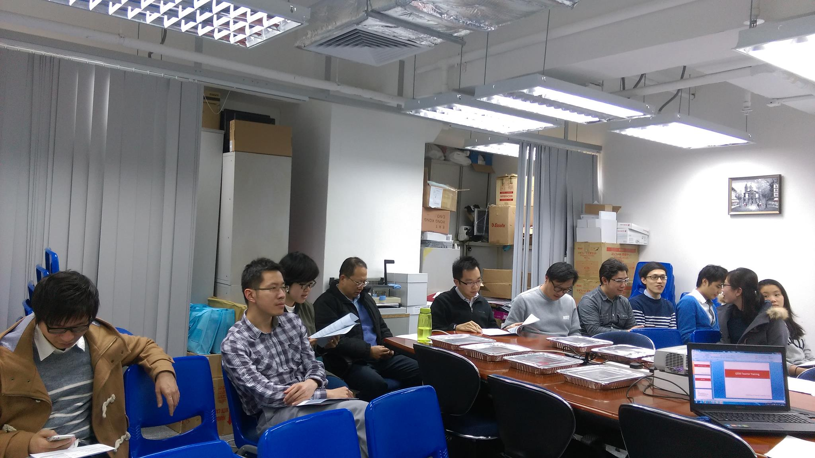
Photo 1. Part of the participants in the session
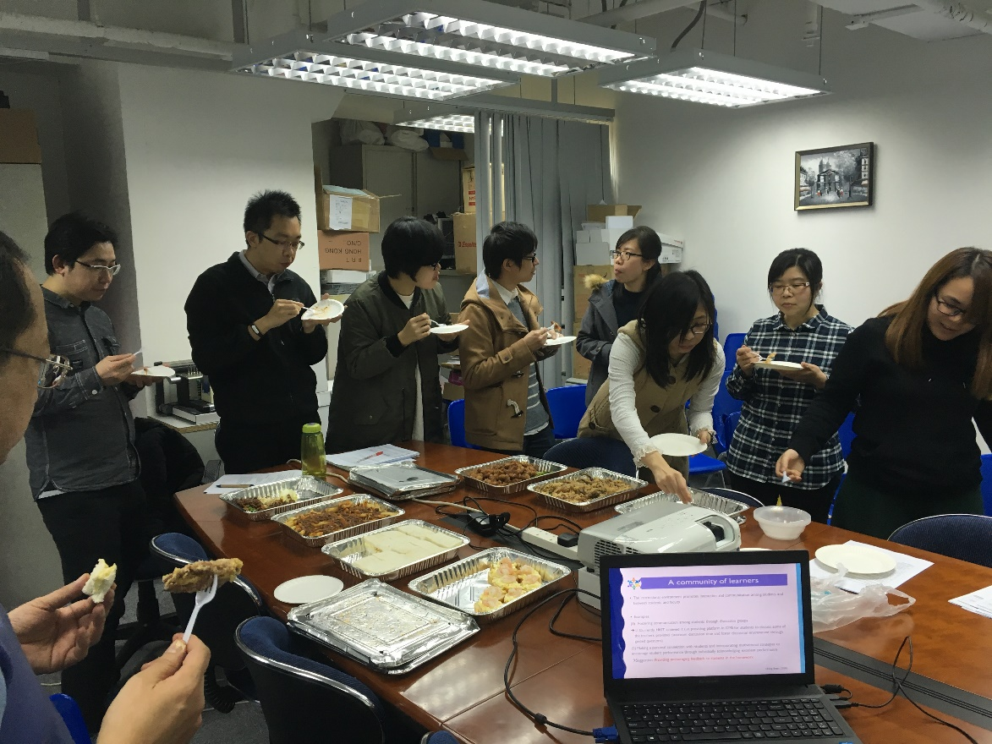
Photo 2. Tea break session

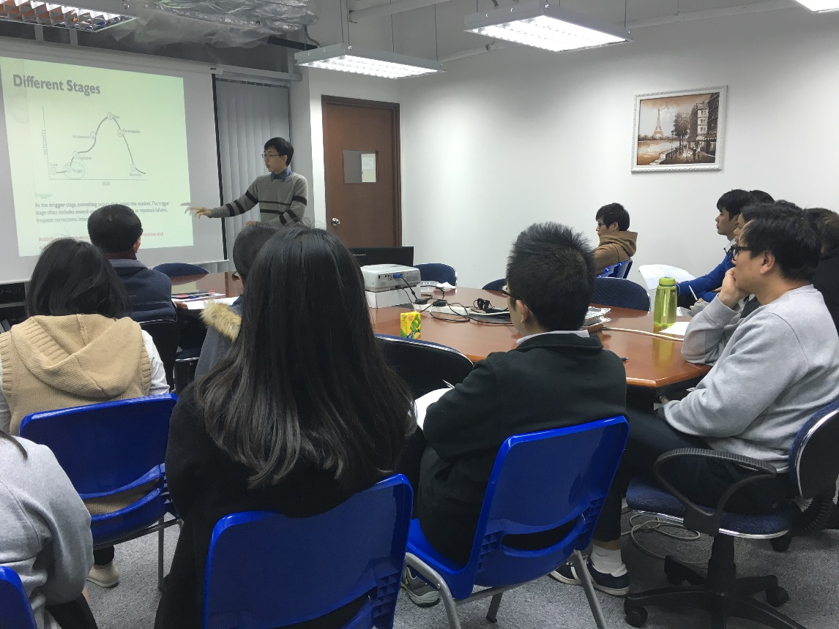
Photo 3. External educational specialist in teacher training session

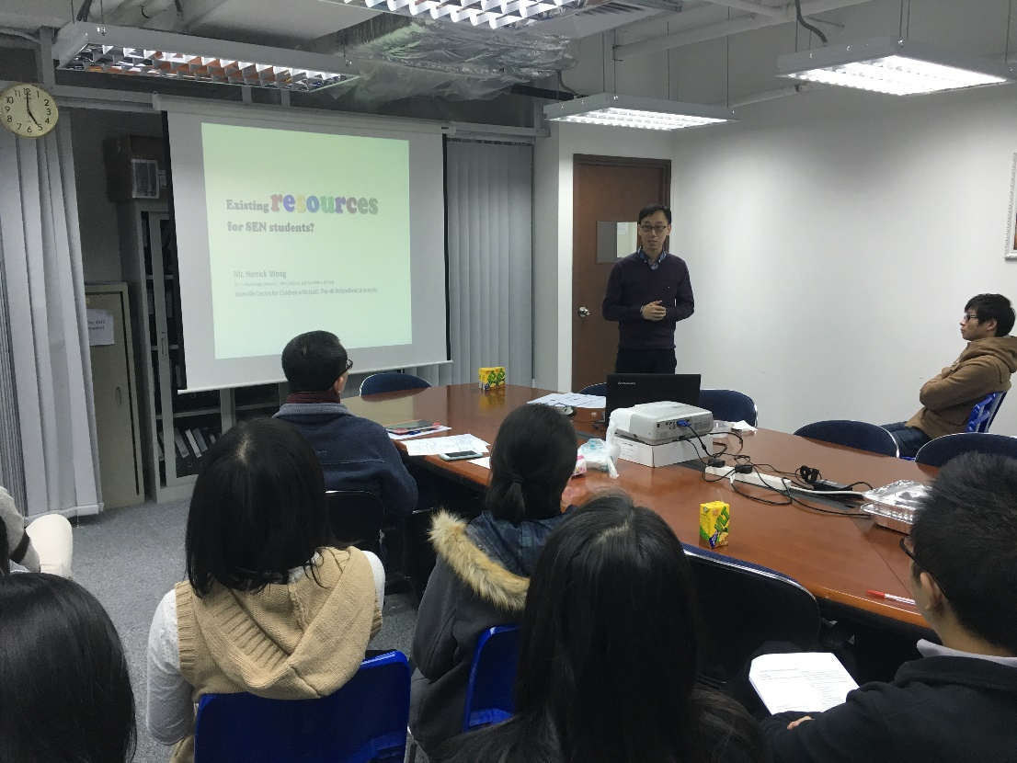
Photo 4. External educational specialist in teacher training session (2)

